B-line
Car Security System
Individual Progress Report – HwanJune Cho

I. Car Controller module
My individual part is design, build and test Car Controller Module Circuit. According to diagram of our project, my module receive data from Mega Arduino then do proper working, or detect current situation of car then transmit data to Mega Arduino module. However, we are just doing each individual part, so I just used my own Aruino instead of Mega Arduino Module. My module consists of several small segment modules, and I’m going to introduce my individual progress of each segment.

- 5V to 12V Amplifier
First of all, to understand Car Controller module, we have to understand about Arduino module’s working condition. In my case, I used Arduino Duemilanove instead of Mega Arduino (Difference between Duemilanove and Megas is just number of pins). Arduino Duemilanove’s operating voltage is 5V, recommended input voltage is 7-12V, digital output voltage is 5V. Here is problem. All of car is work is 12V, however, I want to use digital output from Arduino. So I had to build Amplifier from 5V to 12V.
I’m not sure what kind of type I used, however, first attempt was failed. So I asked about it to Dr.Russmussen because she taught me several amplifiers from ECE2280, then she gave me a hint. Using BJT! After her advice, I rebuilt my amplifier circuit with NPN, BJT, and several resisters.
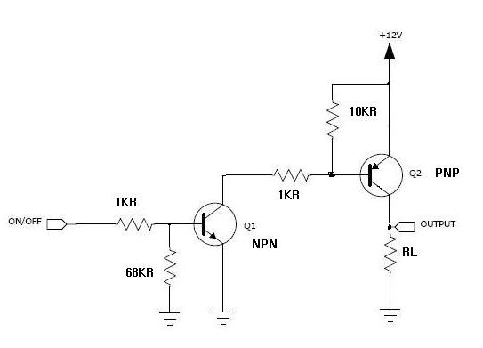
Figure 1. Schematic of Amplifier
After designed and tested circuit, I built real circuit and soldering them. I built 4 amplifiers to control door lock, unlock, lights and horn
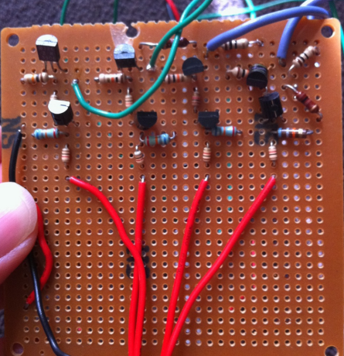
Figure 2. Real Circuit of Amplifier

- Door Lock and Unlock Module
Next, one of main function in our system, if people send text message to car, the door should be locked or unlocked by text message data. To do this function, I should built lock and unlock module. To build this module, I should understand how door lock and unlock in the car. After reading several information, I found each door of car has small motor and it control lock and unlock.
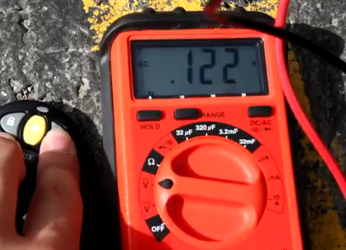
Figure 3. Connect Voltage Meter to Motor in Door

So, I removed every panel of doors then I connected voltage meter to motor as figure 3. After that I found when I push open of remote controller, voltage goes to 12v for 0.3-0.5 seconds then when I pushed close of remote, voltage goes to -12v for 0.3-0.5 seconds. After this experiment, I found this motor work with 12V and -12V, but I was not sure exactly how many seconds should I give (0.3-1second), I just assumed 0.5 seconds for it. So I just designed and built module with Arduino, it connected with 5v to 12v amplifier to make 12V. After that, I tested this module. It worked, but not fully working. Just lock or just unlock. It took several weeks to figure out the problem of it. Finally, I found just two wires of my door lock unlock motor works for it. I mean to unlock the door, when one of wire is positive the other goes to ground, to lock the door, when grounded wire for unlock goes to positive and another one goes to ground. First time of test, there were several wires and ground so I just thought about three wires work for motor, but I was wrong. After finding failure reason, I redesign and rebuilt module and it works perfect. As figure 4, I used extra analog switches to control lock and unlock
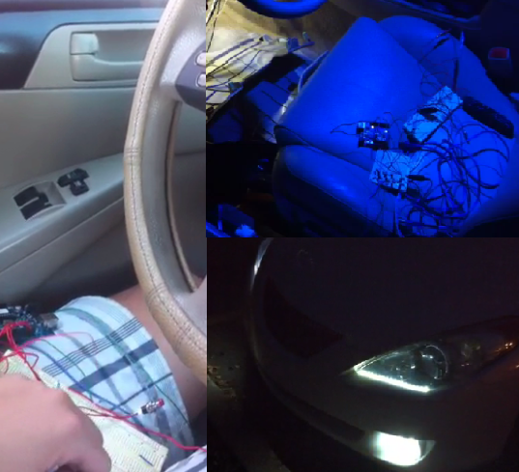
Figure 4. Lock/Unlock Module and Light Module

- Light Module
Our plan is when door is lock or unlock, light blinks several times or when alarm is working, light blinks as Morse signal of ‘S.O.S.’ It was not that hard because light work is just 12V and I can make proper 12V from Arduino. I just found wire for light then connected it with Arduino and it worked.
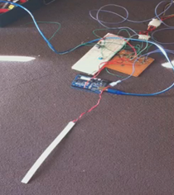
Figure 5. Testing of Light Module

- Ignition Check
When key position is ‘ON’, that means ignition state is ‘ON’. I used Arduino IN pin, when this pin indicate 5V, it means ignition is on. I just used one pin for this module. That’s it.

Part a. to d. I finished until December of 2010. e,f module didn’t finish perfectly.

- Horn Controller
I tried to use additional horn, so I bought it from junkyard. When I test them in Analog Lab in MEB, it was not working. But when I connected them to computer power – it makes 110V to 12V, and horn works for 12V and need lot of currents – it worked. However, I didn’t figur out how can I control it. I took several weeks for it but still working on it.

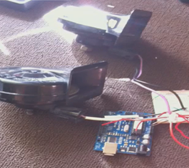
Figure 6. Horn Controller

- Door Indicator
Nowadays, most of car has function of door indicator. I mean, when one of door is open, driver can indicate it from instrument panel. However, we need this function for our project so I need to figure out how it works. After spend several hours, I found every car has push on pull off switches on door, so when door is open this switch is ‘On’, so it can show this data to instrument panel. Actually, I found wires from my car, but I didn’t try to connect it. I think, if I connect it to Arduino, it should work. Furthermore, I need to build Or_gate module, to get data from all of doors and output these data using one wire

